CREATE DATABASE onlinebookstore1;

GRANT ALL ON onlinebookstore.* TO 'Manoj'@'localhost' IDENTIFIED BY '123';

GRANT ALL ON onlinebookstore.* TO 'Manoj'@'127.0.0.1' IDENTIFIED BY '123';

USE onlinebookstore1;

CREATE TABLE customer(customer_id INTEGER PRIMARY KEY AUTO_INCREMENT,

Name VARCHAR(50) NOT NULL,

Email VARCHAR(50) UNIQUE NOT NULL,

Password VARCHAR(50) NOT NULL,

Phone BIGINT(10) UNIQUE check (phone>999999999),

Gender VARCHAR(30) check (gender in('Male', 'Female', 'Others')),

Door_No VARCHAR(20),

Street VARCHAR(30),

City VARCHAR(30)

);

CREATE TABLE Administrator(Admin_id INTEGER PRIMARY KEY AUTO_INCREMENT,

Name VARCHAR(50) NOT NULL,

Email VARCHAR(50) UNIQUE NOT NULL,

Password VARCHAR(50) NOT NULL,

Phone BIGINT(10) UNIQUE check (phone>999999999),

Gender VARCHAR(30) check (gender in('Male', 'Female', 'Others')),

Door_No VARCHAR(20),

Street VARCHAR(30),

City VARCHAR(30)

);

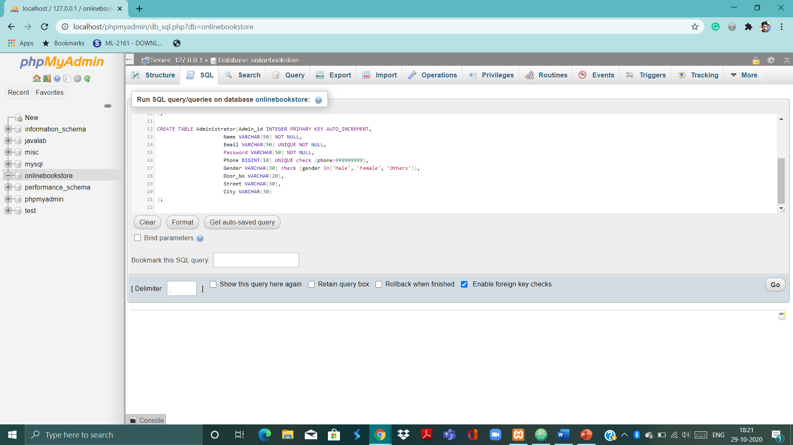

CREATE TABLE Cart(cart_no Integer(11) PRIMARY KEY AUTO_INCREMENT,

customer_id integer(11), FOREIGN KEY(customer_id) REFERENCES customer(customer_id));

CREATE TABLE stock(stock_id Integer(11) primary key AUTO_INCREMENT,

number integer(11) check (number>=0));

CREATE TABLE book(book_id Integer(11) PRIMARY KEY AUTO_INCREMENT,

name varchar(50),

author varchar(50),

year integer(4),

category varchar(50),

publisher varchar(50),

description varchar(1000),

stock_id integer(11), foreign key(stock_id) references stock(stock_id),

admin_id integer(11), foreign key(admin_id) references administrator(admin_id));

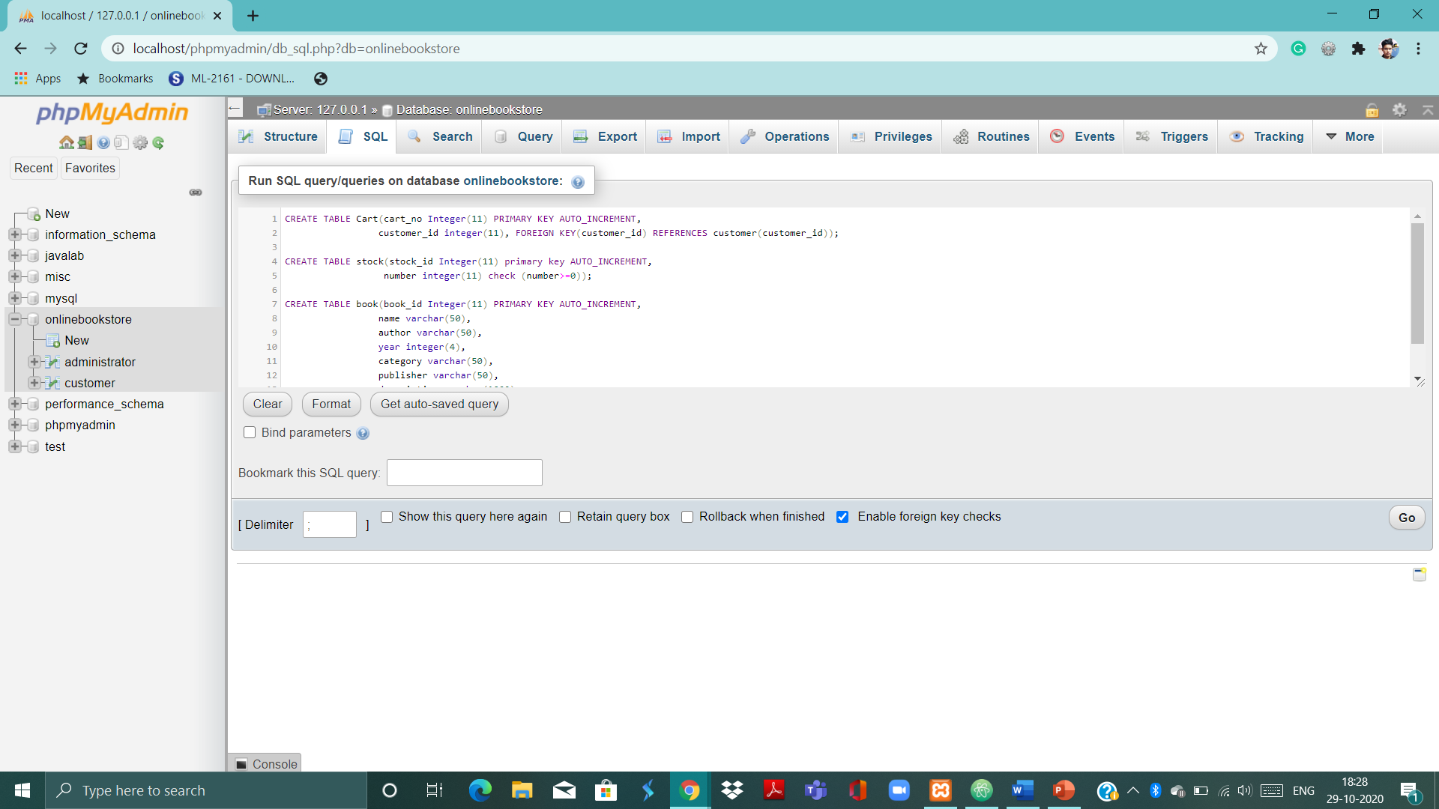

CREATE TABLE order_list(order_id integer(11) primary key AUTO_INCREMENT,

status varchar(50));

CREATE TABLE cart_list(cart_no integer(11), FOREIGN KEY(cart_no) REFERENCES cart(cart_no),

book_id integer(11), FOREIGN KEY(book_id) REFERENCES book(book_id),

no_of_quantity integer(5),

primary key(cart_no, book_id));

CREATE TABLE orders(order_id integer(11), FOREIGN KEY(order_id) REFERENCES order_list(order_id),

cart_no integer(11), FOREIGN KEY(cart_no) REFERENCES cart(cart_no),

customer_id integer(11), FOREIGN KEY(customer_id) REFERENCES customer(customer_id),

primary key(order_id, cart_no, customer_id));

CREATE TABLE review(customer_id integer(11), FOREIGN KEY(customer_id) REFERENCES customer(customer_id),

book_id integer(11), FOREIGN KEY(book_id) REFERENCES book(book_id),

review varchar(1000),

primary key(customer_id, book_id));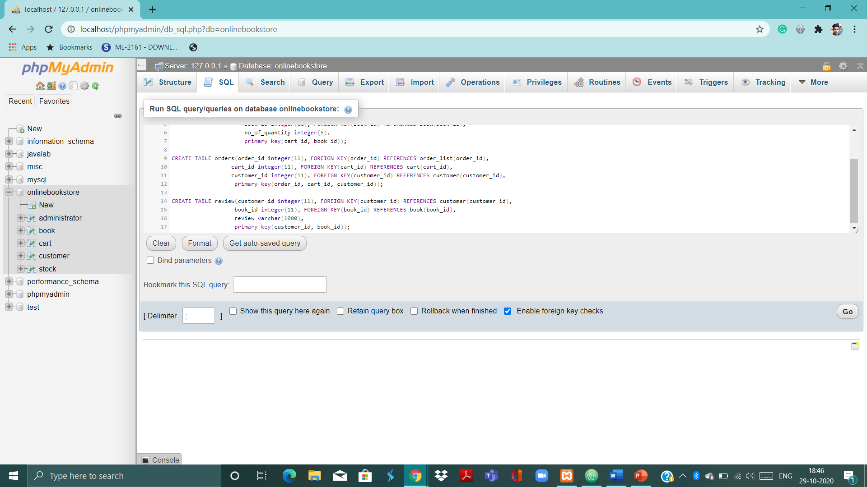

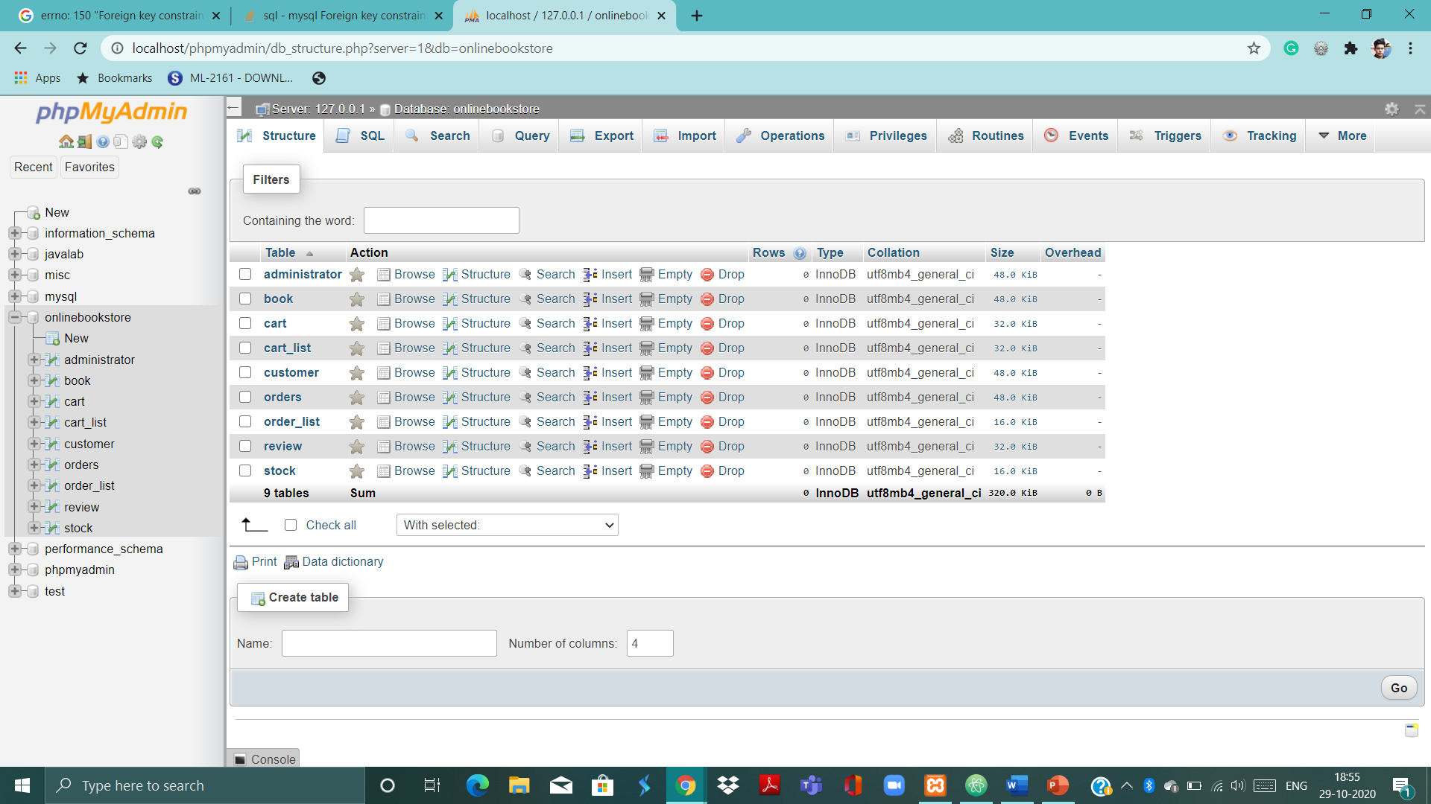

alter table book add image varchar(255);

[alter](http://localhost/phpmyadmin/url.php?url=https://dev.mysql.com/doc/refman/5.5/en/alter-table.html) [table](http://localhost/phpmyadmin/url.php?url=https://dev.mysql.com/doc/refman/5.5/en/alter-table.html) book add price integer(11);

alter table cart add total integer(10);

alter table cart_list add status varchar(30);

alter table order_list add date varchar(30);

alter table order_list add time varchar(50);